 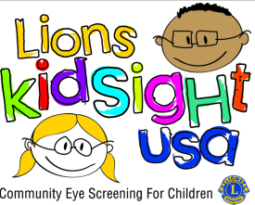

**North Carolina Lions KidSight Information Form**

**Screening Date__________________________**

(Please Print)

**Child’s Name______________________________________________**

**Date of Birth**. **Age___________________**

**Grade_________________ Teacher______________________________**

**Facility Name_______________________________________________**

**Screening Results**

Refraction, pupil sizes and corneal reflexes are measured and compared to age-based referral criteria automatically. Referral criteria and the PlusOptix system screen for:

**Anisometropia** - unequal refraction of both eyes **Myopia** - nearsightedness

**Astigmatism -** corneal irregularities **Corneal reflexes** - symmetric eye alignment

**Hyperopia -** farsightedness  **Anisocoria** – unequal pupil size

If readings are within limits, a "pass" screening result is displayed. If one or more of the readings are outside of limits, a "refer" screening result is displayed. Screening results are displayed on screen immediately after a measurement is completed.

**Child normally wears Glasses? _______** **Child was screened with Glasses? _______**

This Screening Does Not Take the Place of a Complete Eye Exam, nor is the Information Below Adequate for a Prescription.

|  |  |
| --- | --- |
|  | REFERRAL RECOMMENDED |
| **PASSED**  **A finding of PASSED does not guarantee that no problems are present. This screening does not replace a recommended annual eye exam by an eye care professional.** | Child should be examined by an eye care professional.  Information on the attached label may be helpful to the Eye Doctor.  BRING THIS FORM TO |
|  | THE EYE DOCTOR |

(Place Referred Sticker Here) (Place Passed Sticker Here)