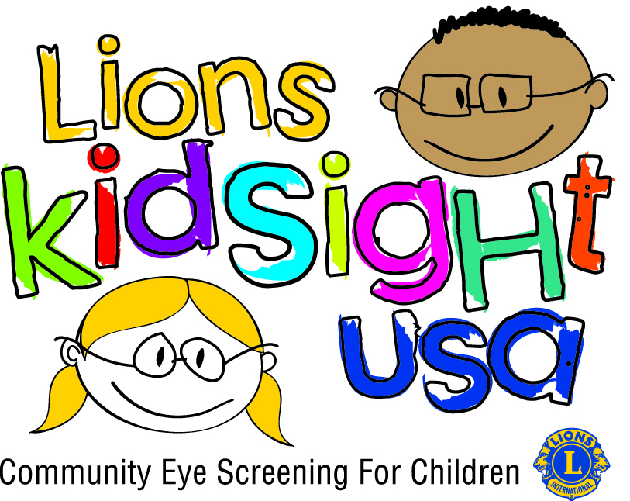
Contact Information
[Name]
[Club Name]
[Phone Number]
[Email]

Children Benefit from Free Vision Screening at Special Lions Club Event

The [club name] partnered with [education program] in [month] to provide free vision screenings for young children. [X number of] children were screened by Lions club members at the event, which took place at [location].

“[quote from education partner],” said [partner spokesperson].

More than 12 million school-age children in the United States have some form of vision problem, yet only one in three have received eye care services before age six.¹ Many vision problems run the risk of becoming permanent if not corrected by age seven, when the eye reaches full maturity. Vision also plays an important role in education. According to educational experts, 80 percent of learning is visual.

“Early screening leads to early detection, which helps ensure that children get the follow-up care they need,” said [club president]. “We want to make sure that correctible vision problems don’t stand in the way of our children learning and seeing the world clearly.”

For information about future screenings or to learn more about the [club name] and its service projects, contact [provide contact info].

The screening event is part of a nationwide initiative called Lions KidSight USA, a national coalition that brings together Lions programs that screen children from 6 months to 6 years of age. KidSight USA was developed by Lions in the U.S. to protect the eye health of America’s children in their early years. Lions in the U.S. currently screen more than 500,000 children per year. Learn more about Lions KidSight USA at KidSightUSA.org.

Lions Clubs International is the largest service club organization in the world. Its 1.35 million members in more than 46,000 clubs are serving communities in more than 200 countries and geographical areas around the globe. Since 1917, Lions clubs have aided the blind and visually impaired, championed youth initiatives and strengthened local communities through hands-on service and humanitarian projects. Learn more about the North Carolina Lions Club at nclf.org.

